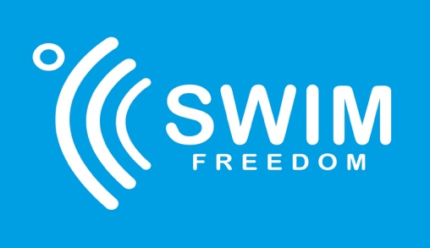

Terms and Conditions

Registration

Registration is for services by Swim Freedom: Open Water coaching, 1-2-1 sessions, consultancy (“Swim Freedom”). You agree that you will abide by the rules and regulations set out by Swim Freedom. You accept that the coaching sessions will take part in an open water venue not run nor managed by any third party.

Swim Freedom always endeavours to run a safe and professional swim coaching programme at all times for all participants and always aims to do so in a professional and courteous manner. Any complaints can be made in confidence and in writing to the proprietor, Kate Gillwood, at gillwoodopenwater@gmail.com
Behaviour

Given the inherent dangers in swimming, you must obey all instructions and commands issued by Swim Freedom. In the event of you refusing to obey an instruction or behaving in an unruly manner, you shall not be permitted to continue with the lessons. In such circumstances Swim Freedom has the right to terminate the contract and refuse you for any lessons.

Health

By registering for a lesson, you agree that you are physically fit, have no illness or injury preventing you from participating in open water swimming and have not been informed by a doctor not to undertake exercise. If you have any medical or other health condition that may affect your ability or may otherwise require modified coaching sessions, you agree to disclose this via the health questionnaire provided by Swim Freedom. If you choose not to disclose this, you do so at your own risk.
Privacy & Security Policy

Swim Freedom will never sell trade, rent, exchange or otherwise share your personal information with any other person, company or organisation, unless your consent has been obtained. Swim Freedom will hold any personal information l only for the duration of the lessons. Once the lessons have been completed, any personal information will be permanently destroyed.
Updates to terms and conditions
These terms and conditions may be updated at any time. If any updates are made, they will be shared with existing clients of Swim Freedom.

Business Address

54 Brunstane Road, Edinburgh EH15 2QR. The current business name is Swim Freedom which may change in the future. Any change will be communicated to existing clients.
Payment

Payment must be made prior to the start of lesson.

Cancellation and Refund Policy
- Cancellations more than 7 days from the lesson start date: a full refund will be given.
- Cancellations less than 7 days and more than 24hours from the lesson start date: a partial refund will be given minus reasonable administration costs.
- Cancellations less than 24 hours to the lesson start date: no refund will be given.
- In the event of a no show or no attendance at the lesson – no refund will be given.
- Once a lesson has commenced, no refund is permitted in the event of it being discontinued.
- Where a lesson has to be cancelled due to environmental issues: Swim Freedom will attempt to offer the lesson on another date.
- Where a course of lessons has to be terminated because of behaviour: a refund will be given for any remaining lessons in the course, minus any reasonable administration costs.

